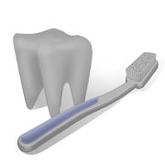


Nellie’s Kids Questions and Answers that Most Parents want to Know!
NELLIE’S KIDS DENTAL OUTREACH PROGRAM
901 525-3800 No Memphis/ 901 346-8286 Whitehaven/
901 795-0200 Hickory Hill
Firestone Dental Group, P.L.L.C
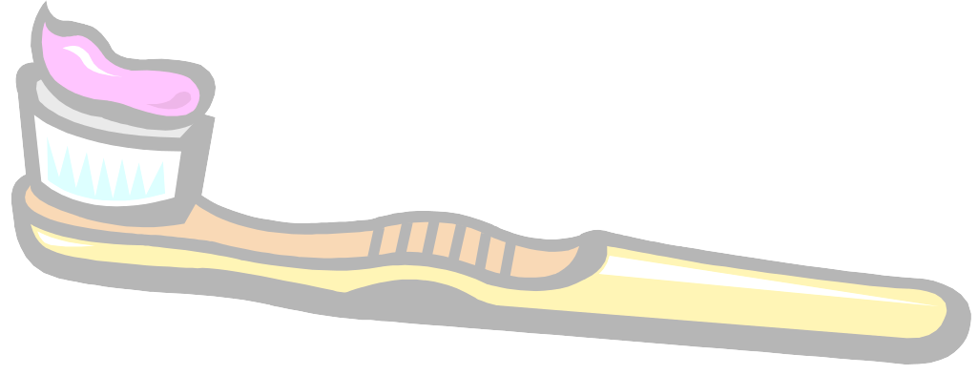
Q: Is breast-feeding better than bottle-feeding in preventing early childhood cavities?

A: Many experts recommend breast-feeding over bottle-feeding for the overall health of your child. However, breast-feeding can lead to Early Childhood Cavities in the same way that bottle-feeding can.

To prevent Early Childhood Cavities:
- Avoid overnight feeding, such as bringing baby to bed with you and allow him/her to nurse at will. Milk can "pool" in the child's mouth and cause acid to form continuously throughout the night. This acid leads to decay.
- After you breast-feed, you still need to clean baby's gums daily with a clean, damp washcloth; a finger cot; or a gauze square.
- The American Dental Association recommends that you encourage your child to drink from a cup by his/her first birthday.

Q: Is it okay if my child sucks his/her thumb?

A: Thumbsucking is normal for infants; most stop on their own by age 2.
- If your child sucks his/her thumb beyond age 2, try to discourage it by age 4.
- Thumbsucking beyond age 4 can lead to crooked, crowded teeth and/or bite problems.

Q: Is it okay for my baby to use a pacifier?

A: Yes, but don't dip it in sugar, honey, or sweetened liquid. In addition:
- Try to have your child give up the pacifier by age 2.
- Keep in mind that while a pacifier and thumb sucking create no health difference for the child, a pacifier may be a better choice because it can be easier to wean child from a pacifier than from thumb sucking.
Q: When should I start cleaning my baby's teeth/gums?

A: Begin cleaning baby's gums within the first few days of birth.
- Use a clean, wet washcloth, a finger cot, or a gauze square. This gets baby used to having his/her mouth feel clean!
- Daily brushing should begin once the first tooth has erupted — but continue to clean and massage gums where there are no teeth yet.
.

BASIC QUESTIONS THAT MOST PARENTS WANT TO KNOW!

Q: What is the best way to brush a toddler's teeth?

A: Use a small, soft-bristled brush. Use a circular or wiggling motion on all tooth surfaces, especially where the tooth meets the gumline. Once your toddler is able to spit out, use a pea-sized amount of fluoride toothpaste on the brush. Families should ask their dentist to demonstrate proper toothbrushing during the child's dental visit.

Q: Can I transmit harmful bacteria that may affect my baby's teeth?

A: Yes. Cavity-causing germs can be transmitted through contact — like when baby puts hands in your mouth, and then in his/her own mouth. That's why it's so important to keep your own teeth and gums healthy.
In addition, research has shown that since a pregnant woman shares blood with her unborn baby, any infection of the mouth — such as a cavity or gum (periodontal) disease — can affect the baby. According to the National Institute for Dental and Craniofacial Research at the National Institutes of Health, oral disease/infection has also been linked to such conditions as preterm, low birth weight babies.

Q: When should I start using fluoride toothpaste for my child?

A: When your child is able to spit. Fluoride is safe and necessary to keep teeth strong, but only at appropriate levels. Younger toddlers tend to swallow toothpaste in excessive amounts, and this may lead to fluorosis, which causes discoloration of the teeth. And remember — even if your water is fluoridated, you still need to use fluoride toothpaste. Fluoride is necessary in both "topical" forms — like toothpaste, and "ingested" forms — like water or fluoride supplements.

Q: I use bottled water at home, and it's not fluoridated. Is this okay?

A: If you use bottled water for drinking and cooking — or if your community water is not fluoridated — be sure to tell your doctor or dentist. They may prescribe fluoride supplements for the baby.
NELLIE’S KIDS DENTAL OUTREACH PROGRAM
901 525-3800 No Memphis/ 901 346-8286 Whitehaven/
901 795-0200 Hickory Hill
Firestone Dental Group, P.L.L.C

